Schedule 1
Time | Activity
3 to 3:30 pm | Snack (choose, prepare, eat, clean up)  Provide child with as much assistance as needed.  Choose Prepare Eat Clean up  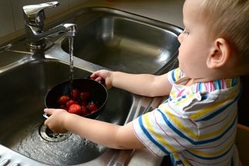 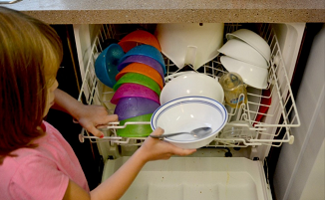\
3:30 to 4 pm | Free Play  Have child assist with taking out a variety of games/toys that he/she likes. Have approximately 5 to 10 toys, games, items. Incorporate toys that allow for movement, focus, exercise, and sensory input-have child help put toys away when done, with guidance if needed! Child may play with toys provided, ask for something else, or walk around. It is “free play” so the choice is theirs.  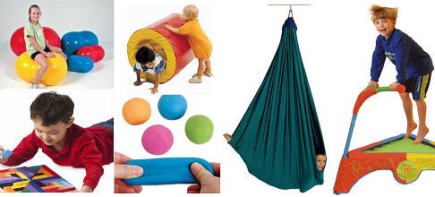
4 to 4:20 pm | 20 Minutes of Exercise (e.g., yoga/dance to music/jumping jacks/take a walk with family/jump on the trampoline - it doesn’t have to be perfect-let them do it their way-kids who have trouble with coordination may have trouble doing some moves correctly)
4 to 5:00 pm | Activity of choice (e.g., favorite game, toy, or show)

Schedule 2
Time | Activity
5 to 5:30 pm | Help cook/set table with as much support/guidance as needed  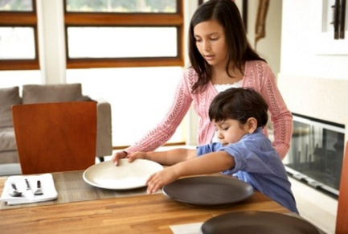
5:30 to 6 pm | Eat/Clean Up  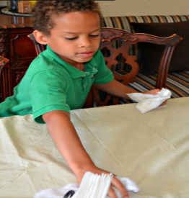
6:00 to 6 pm | Free Play (have child help take out and put toys away when done)

Schedule 3
Time | Activity
6:30 to 7 pm | Help mom/dad with chores-give choices (e.g., vacuum, carry laundry basket, take out garbage)  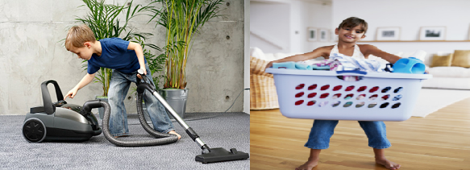
7 to 7:30 pm | Screen Time (you earned it!!) (e.g., Computer/IPAD/Tablet/Phone )
7:30 to 7:45 pm | 15 Min Exercise (pushups/trampoline/dance video/etc.)
7:45 to 8:15 pm | Night time snack (child can help choose, prepare, clean up)

Schedule 4
Time | Activity
8:15 to 8:45 pm | Brush Teeth/Take a Bath/Put on Pajamas  Teeth Bath Pajamas
8:45 to 9:00 pm | Laydown/Relax/Unwind with Weighted Blanket - may want to look at book or play with sensory item such as a fidget toy.
9:00 pm | Bed Time (what a productive day!)
 | educationandbehavior.com

