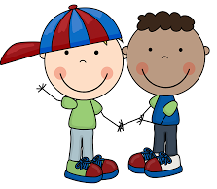
Be Kind
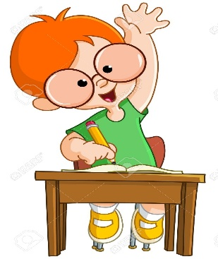
Raise Your Hand if You Have a Comment or Question

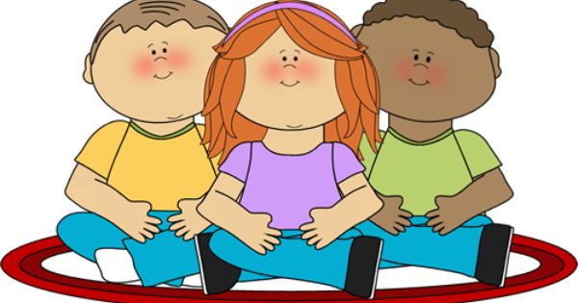
Keep Your Hands and Feet to Yourself
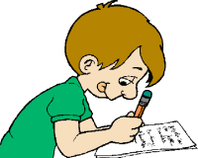
Do Your Best to Follow Teacher Directions and Complete Your Work

