SENTENCE COMBINING WORKSHEET
Directions: For each example, rewrite the kernel sentences (Base Clause and Sentence to Be Combined or Embedded) and then write the solution.
There is one practice problem per page
Base Clause: Apartment buildings in the city were damaged in the earthquake.
Sentence to Be Embedded: Stores in the city were damaged in the earthquake. (and)
Solution: Apartment buildings and stores in the city were damaged in the earthquake.
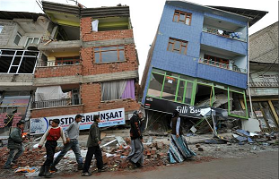

Base Clause: When going on a trip, bring your clothes.
Sentence to Be Embedded: When going on a trip, bring your toothbrush. (and)
Solution: When going on a trip, bring your clothes and your toothbrush.
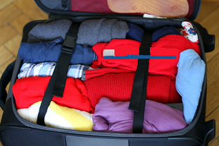

Base Clause: Strong winds can cause damage to property.
Sentence to Be Embedded: Heavy rain can cause damage to property. (and)
Solution: Strong winds and heavy rain can cause damage to property.
.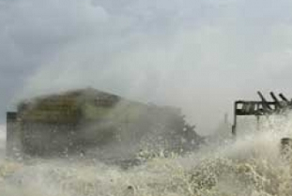

Base Clause: The girl ran to school.
Sentence to Be Embedded: The girl also ran quickly.
Solution: The girl ran quickly to school.

Base Clause: The Girl Scout was selling cookies.
Sentence to Be Combined: No one had money. (but)
Solution: The Girl Scout was selling cookies, but no one had money.

Base Clause: The boy was happy.
Sentence to Be Combined: He got his favorite toy for his birthday. (because)
Solution: The boy was happy because he got his favorite toy for his birthday.

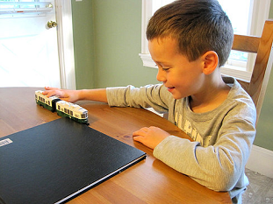

Base Clause: The dog caught the Frisbee ten times.
Sentence to Be Embedded: The dog is an expert at playing catch.
Solution: The dog, an expert at playing catch, caught the Frisbee ten times.

Base Clause: A girl on my street loves the black dog named Barkley.
Sentence to Be Embedded: Barkley belongs to my neighbor.
Solution: A girl on my street loves my neighbor's black dog named Barkley.
